The WKU Center for Economics Education is sponsoring a FREE professional development opportunity!
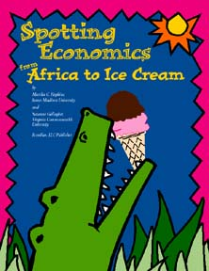
Ever wonder how to integrate economics concepts into your social studies, reading, and math lessons? Join other elementary and middle school teachers as we explore lessons from Spotting Economics from Africa to Ice Cream, Adventures in Economics and U.S. History, and K thru 2 Can Do!
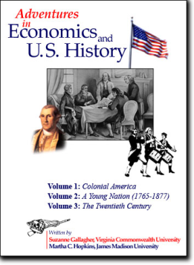
Exploring Economics!
Audience: Elementary and middle school teachers - Grades K-8; Curriculum coordinators
Time: Tuesday, March 24, 2015; 4:30 – 7:00 p.m.
Location: WKU, Gary Ransdell Hall, Room 3002
Presenter: Dr. Jana Kirchner, Assistant Professor, Director of WKU Center for Economics Education, WKU
*The first 25 participants to register and attend will receive a copy of one of the following: Adventures in Economics and U.S. History, Spotting Economics, or K thru 2 Can Do!
*Discuss the economics content and skills in Kentucky’s new draft social studies standards while engaging in student-centered economics lessons for grades K-8:
*Examine needs and wants while reading Robert McCloskey’s Blueberries for Sal.
*Spot economics in Marjorie Priceman’s How to Make an Apple Pie and See the World.
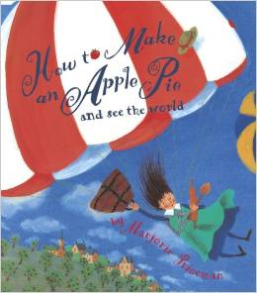
*Locate examples of markets, consumers, and producers in Donald Hall’s Ox Cart Man.
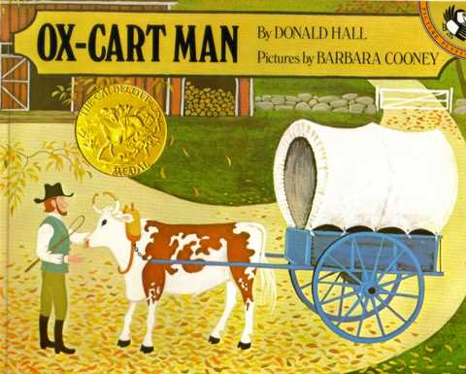
To Register: E-mail Dr. Kirchner at jana.kirchner@wku.edu
(If you need a parking pass, let Dr. Kirchner know when you register.)

