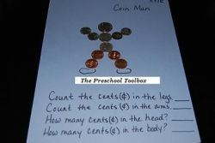
Making COIN PEOPLE

Materials needed: A basket of assorted real, paper, or plastic coins, poster putty, and construction paper.
Let the children be creative with the coins to assemble them into the shape of a coin person. The children can use any coins they wish to make the head, body, arms, and legs. When the children are finished designing their coin person, have them count how many CENTS make up each body part (for ex. the child made legs out of 4 pennies - the legs would be made up of FOUR CENTS; if they made a body out of two dimes, the body would total 20 CENTS, and so on.) It is FUN for the kids to assemble the COIN PEOPLE and a great way to extend lessons about CENTS.
http://www.pinterest.com/pschooltoolbox/money-themed-activities-for-preschool-and-kinderga/

