Coin Toss

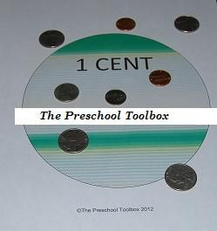
Materials needed: One copy of the COIN TOSS MATS (see pdf file) and assorted coins
Print the pages of the pdf file to heavy paper. Lay the individual pages out on the floor (if desired, the pages can be laminated to play outside.) Tape a "starting line" behind the pages (for younger children, tape the line closer to the "targets.") Set out a basket of assorted coins and let the children toss the coins. The children should try to toss the coin to the corresponding target (for ex: the quarter should ideally land on the 25 CENTS page.) After all the children have had turns to toss the coins, count the number of coins that were tossed to the corresponding CENTS target. Make a graph with the children to show how many pennies, nickels, dimes, and quarters were tossed onto the corresponding "CENTS" targets. *To make the game a little more challenging, count only the number of coins that landed INSIDE the corresponding target area.

Source: www.scribd.com

