

**The WKU Center for Economics Education is sponsoring a FREE professional development opportunity!**

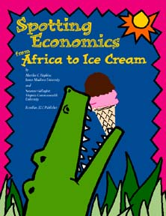**Ever wonder how to integrate economics concepts into your social studies, reading, and math lessons? Join other elementary and middle school teachers as we explore lessons from *Spotting Economics from Africa to Ice Cream, Adventures in Economics and U.S. History,* and *K thru 2 Can Do!***

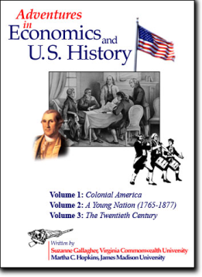 **Exploring Economics!**

**Audience:** Elementary and middle school teachers - Grades K-8; Curriculum coordinators

**Time:** Tuesday, March 24, 2015; 4:30 – 7:00 p.m.

**Location**: WKU, Gary Ransdell Hall, Room 3002

**Presenter:** Dr. Jana Kirchner, Assistant Professor, Director of WKU Center for Economics Education, WKU

**\*The first 25 participants to register and attend will receive a copy of one of the following: *Adventures in Economics and U.S. History, Spotting Economics, or K thru 2 Can Do!***

*Discuss the economics content and skills in Kentucky’s new draft social studies standards while engaging in student-centered economics lessons for grades K-8:

*Examine needs and wants while reading Robert McCloskey’s *Blueberries for Sal.*

*\**Spot economics in Marjorie Priceman’s *How to Make an Apple Pie and See the World.*

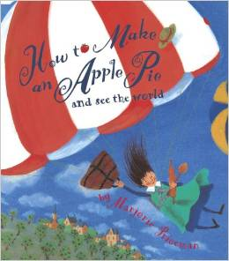*Locate examples of markets, consumers, and producers in Donald Hall’s *Ox Cart Man.*

*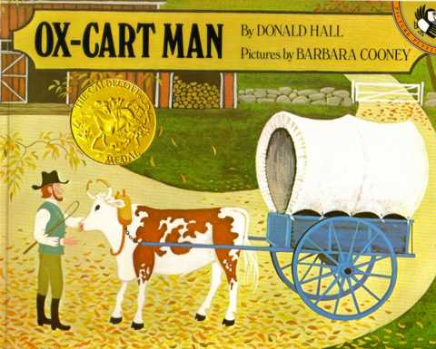***To Register:** E-mail Dr. Kirchner at [jana.kirchner@wku.edu](mailto:jana.kirchner@wku.edu)

(If you need a parking pass, let Dr. Kirchner know when you register.)